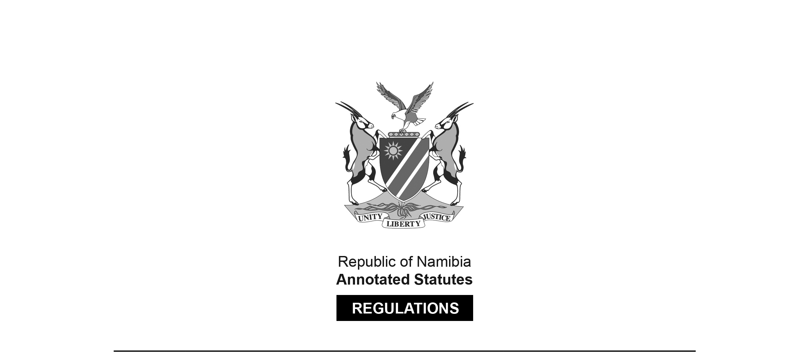
REGULATIONS MADE IN TERMS OF

Hospitals and Health Facilities Act 36 of 1994
section 38 read with sections 23(2) and 31(2)

Regulations relating to Registration and Licensing Fees for Private Hospital and Private Health Facilities
Government Notice 27 of 2026
(GG 8855)
came into force on date of publication: 27 February 2026

ARRANGEMENT OF REGULATIONS

[This document consists of a single unnumbered regulation.]

Fees for issue and renewal of registration of private hospital and licence of private health facility

Fees for issue and renewal of registration of private hospital and licence of private health facility ––

(a) a person, who makes an application for the issue or renewal of the registration of a private hospital or licence of a private health facility, must pay the prescribed fee as set out in the Table; and

(b) the registration or licence fees –

(i) for new applications are indicated in column 1 of the Table; and(and

(ii) for the renewal of the registration of a private hospital or the renewal of a licence of a private health facility, may be renewed after a period of 12 month as indicated in column 2 of the Table.
Table

Fees
Column 1 |  | Column 2
New applications |  | Renewals (every 12 months)
Clinic | N$6 500 | Clinic | N$3 250
Consulting room of a practitioner | N$9 000 | Consulting room of a practitioner | N$4 500
Laboratory | N$9 000 | Laboratory | N$4 500
Mobile clinic | N$4 250 | Mobile clinic | N$2 125
Ambulance | N$4 250 | Ambulance | N$2 125
Convalescent home | N$9 000 | Convalescent home | N$4 000
Orthopaedic workshop | N$4 250 | Orthopaedic workshop | N$2 125
Community health centre | N$4 250 | Community health centre | N$2 125
Occupational health clinic | N$4 250 | Occupational health clinic | N$2 125
Maternity home | N$4 250 | Maternity home | N$2 125
Unattached delivery suite | N$4 250 | Unattached delivery suite | N$2 125
Dental laboratory | N$6 750 | Dental laboratory | N$3 375
Health spa/hydro | N$4 250 | Health spa/hydro | N$2 125
Sanatorium | N$4 250 | Sanatorium | N$2 125
Pharmacy | N$9 000 | Pharmacy | N$4 500

